What’s CADR?

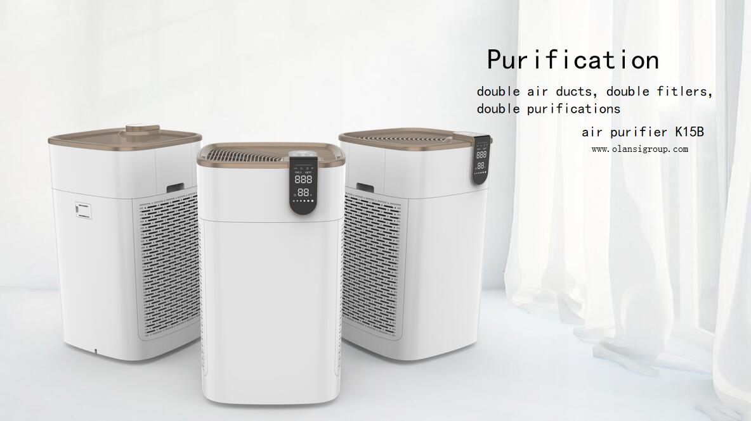

CADR refers to the ratio of air purifier output clean air obtained by the American Association of Home Appliance Manufacturers (AHAM) according to strict test standards. The higher the CADR value, the higher the purification efficiency of the purifier.

Often used to indicate the purification efficiency of the air purifier.

The performance of the air purifier is mainly determined by the clean air output ratio (CADR [1] value). The higher the clean air output ratio, the higher the purification efficiency of the purifier. To make the indoor air quality reach a certain clean standard, the air purifier has two necessary hard indicators. 1. The indoor air must be guaranteed to reach a certain number of air changes (international 5 times); 2. One purifying of the air purifier Efficiency must be high. These two hard-index air purifiers keep indoor pollutants at a lower concentration if there is a continuous source of pollution in the room.

First, it must be ensured that the indoor air reaches a certain number of air changes, that is, the fan built in the air purifier has a certain amount of air. The international standard is to ensure that the air is ventilated five times per hour in the applicable area.

Take an air purifier for example:  
The calculation formula for the applicable area of the air purifier:  
Applicable area S (m2) = 12F/60H  
among them:  
5 times per hour, every 12 minutes;  
F = the maximum air output of the air purifier, the unit is cubic meters / hour;  
H = height of the room, generally 2.8 meters.  
For example, in an air purifier, the maximum air volume F is 400 cubic meters per hour, and the area S to which the air purifier is applied is calculated as:  
S = 12 × 400 / (60 \* 2.8) = 28.57 square meters  
The room size of the air purifier is approximately 30 square meters if other factors such as the effective volume of the room are considered.  
The TB400 has an air volume of 400 cubic meters per hour, so the floor area is about 2.8 meters per hour at 30 square meters.  
400 / (30×2.8) = 4.7 times, then calculate the volume, about 5 times per hour.  
Second, the primary purification efficiency of the air purifier must be relatively high, and the higher the purification efficiency (CADR), the better the air purifier is.  
The Purification Efficiency (CADR) value has three indicators:  
1, dust (Dust);  
2. Secondhand smoke (Tobacco Smoke);  
3. Pollen (Pollen).

The CADR value is the physical quantity that can quantitatively characterize the two necessary conditions above the air purifier.

The larger the CADR value, the higher the purification efficiency of the air purifier. Using the CADR value, you can evaluate the air purifier in operation.

After a certain period of time, the effect of indoor air pollutants is removed.

If there is a continuous source of pollution in the room, use an air purifier with a large CADR value to keep indoor pollutants  
At lower concentrations.  
From this point of view, although there are many such air purification products on the market, as long as they are measured by these two conditions, like a demon mirror, all true and false will come out.

From：http://www.olansigroup.com/2084.html